CSD-4464 Programming Java EE

WEEK 8

Assignment 4

Date: 18th March 2022

Output

Group E Members:

Anirudh Vallampatla C0796429

Meghana Kondaveeti C0784302

Srikanth Ajith Kumar Yarram C0793406

Vishal Kumar C0793379

Yamini Rathod C0796390

After Registration, It would redirect to Login page

Login using incorrect credentials

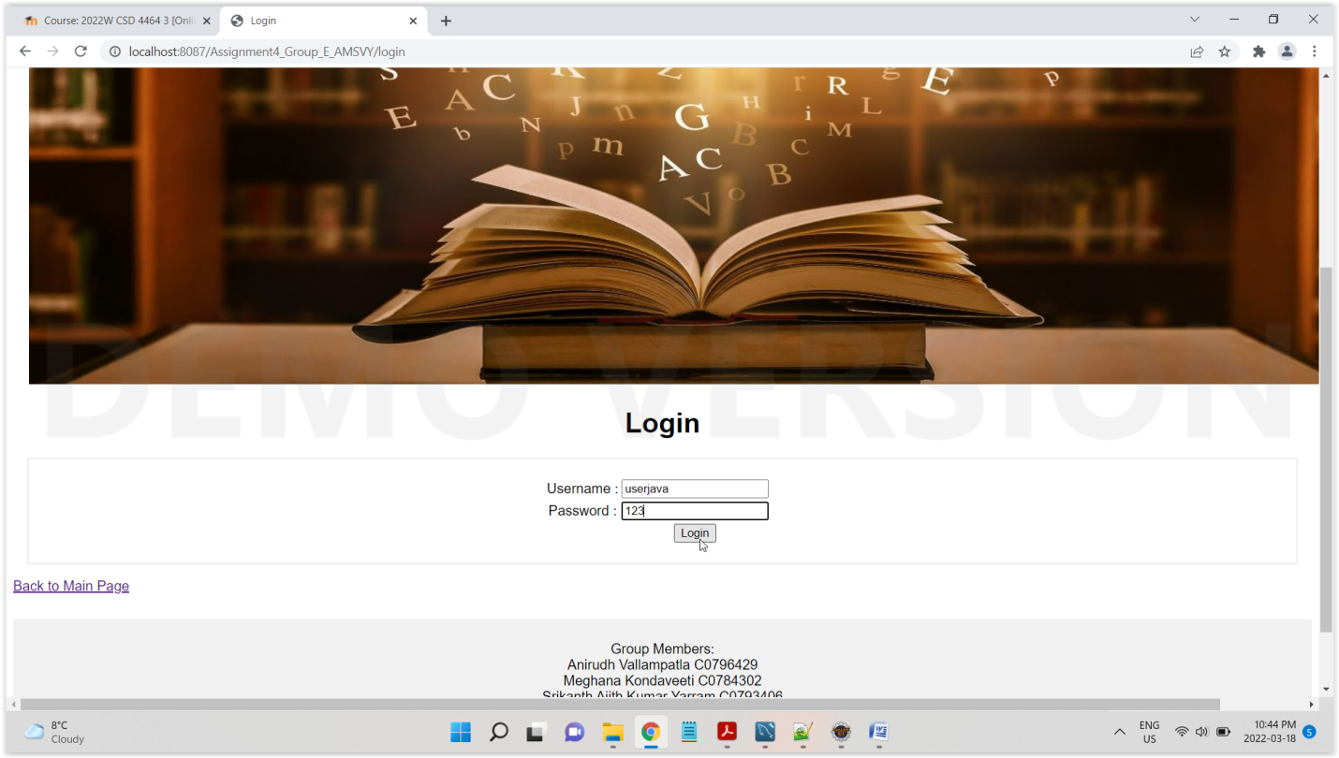

It would redirect to login failed page

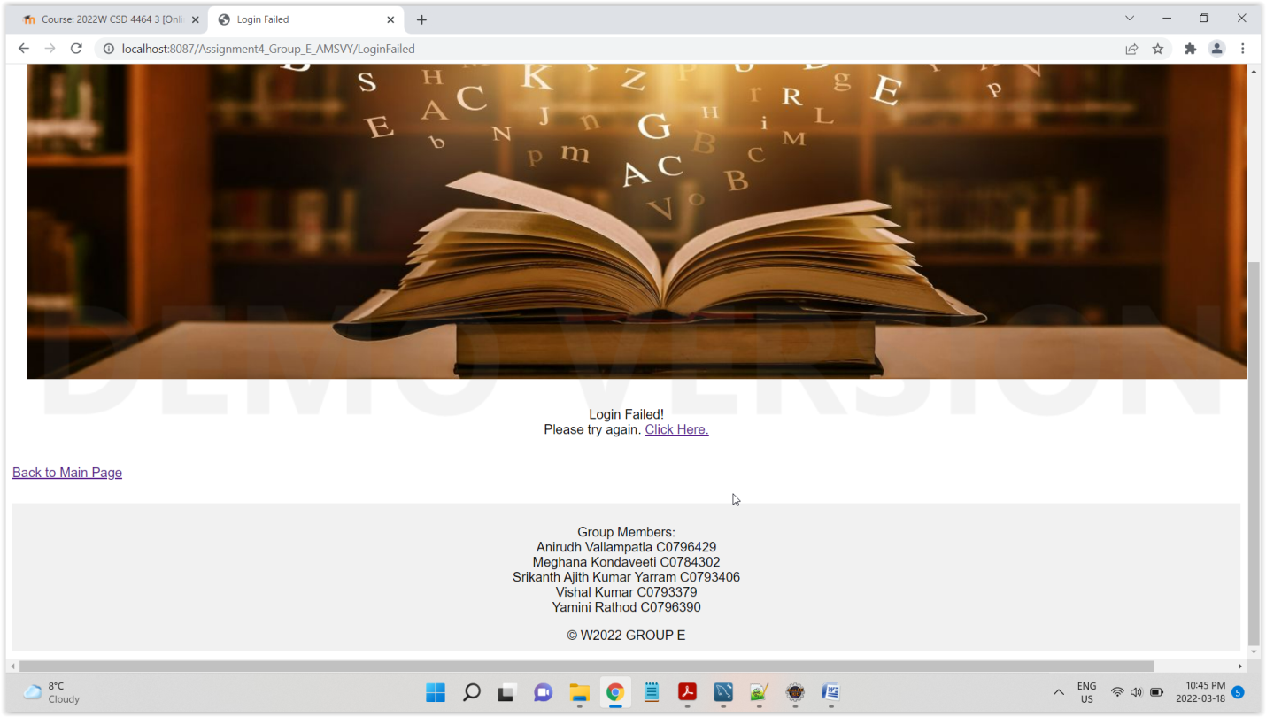

Try with correct credentials

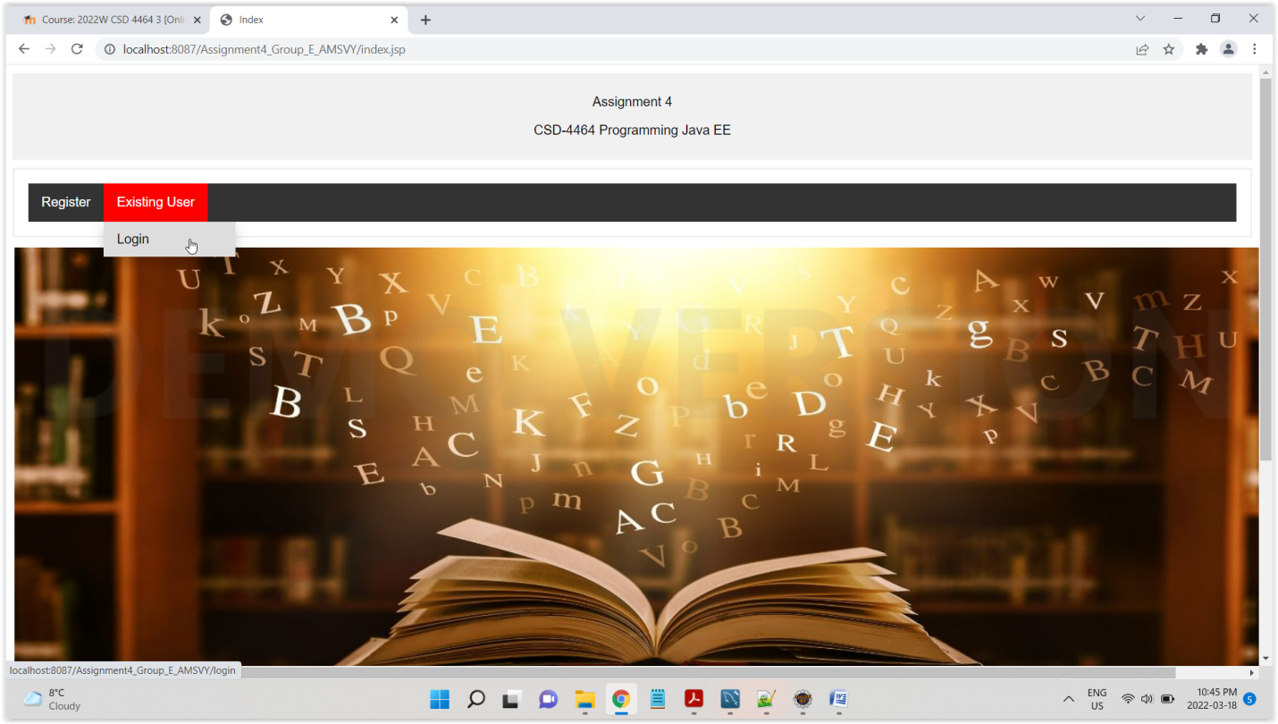

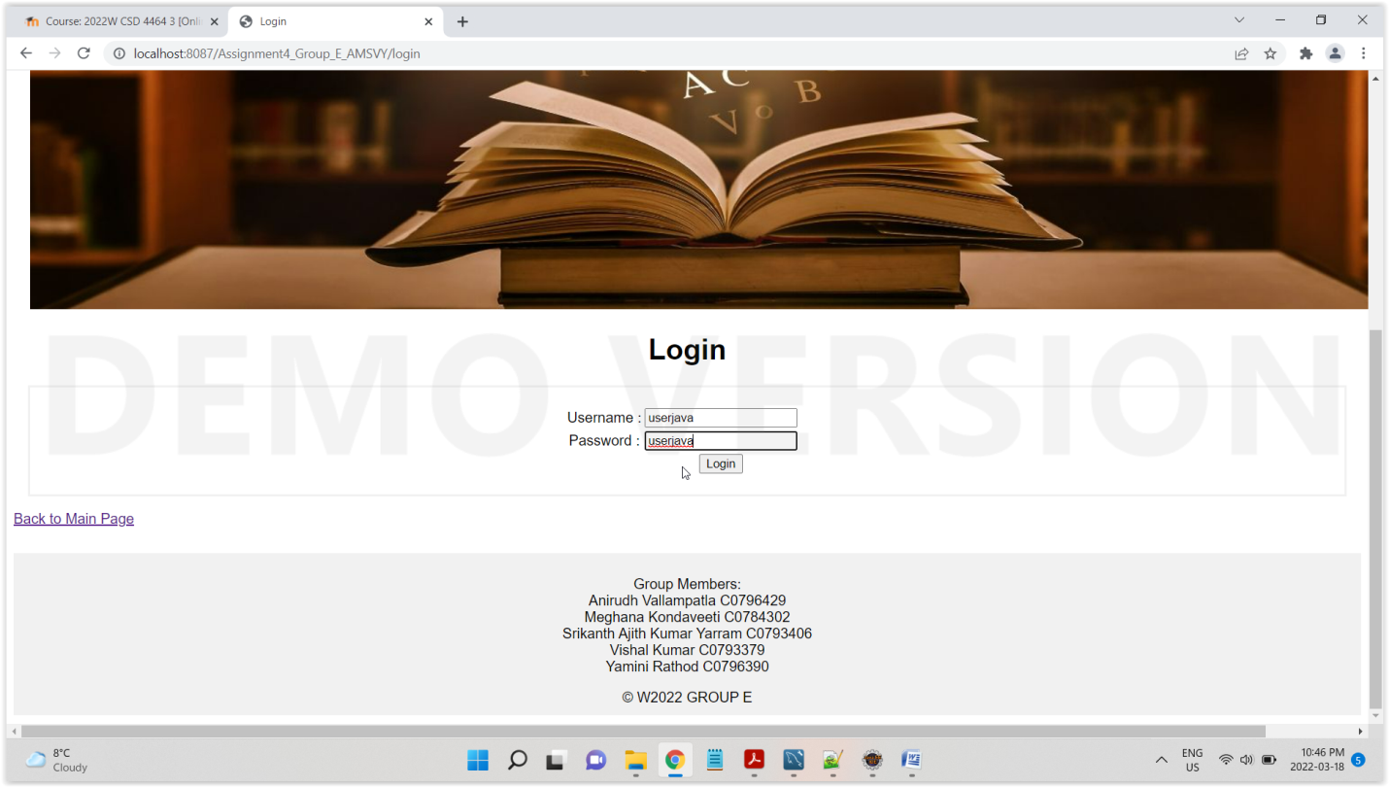

It would redirect to home page

